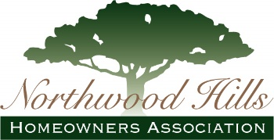
Membership Form

___ I am a current member confirming my contact information.

___ I am unsure of my membership status; please contact me.

___ I am a NEW MEMBER.

NHHA dues are $350 for the calendar year. If paying by check, you
may pay the full year, semi-annually, or quarterly. Online payments are accepted for the full year amount via Paypal or major credit card.

Mail this form w/payment to: NHHA, PO Box 800874, Dallas, TX, 75380-0874.
NAME (please print for legibility) Cell Phone Email

SPOUSE'S NAME Cell Phone Email

ADDRESS Home Phone

If we could use help in the future, please let us know your areas of interest.
□ Security/Crimewatch □ Independence Day Parade
□ Beautification □ Membership Recruitment
□ Special Events & Programming □ Marketing/Advertising
□ Other______________________________

If you have questions about NHHA membership, benefits or programs, please email membership@northwoodhills.org.

NHHA | P.O. Box 800874 Dallas, TX 75380-0874 | www.northwoodhills.org

